Deep Unsupervised Image Segmentation

Data Acquisition and Preprocessing Report
2/17/2021

Identifying Data

Data Sources:

Below is the first dataset that we will be using. It is a dataset that contains 7,390 images of dogs and cats as well as the ground truth masks for those images. Each pixel in the ground truth masks has a label of one, two, or three. A label of one is considered the background, two is the outline of the animal, three is the animal. The images have a variation in scale, pose, and lighting.
- https://www.robots.ox.ac.uk/~vgg/data/pets/

Below is our second dataset that we will be using. It is the Aerial Semantic Segmentation Drone Dataset. The dataset contains 400 pictures that were taken from a drone while it was in the air anywhere from five to thirty meters. This is a much more complex dataset than the pets dataset. This dataset also contains raw images as well as ground truth masks for each image. There are 23 different class labels that can be associated to an individual pixel. The 23 classes are tree, gras, other vegetation, dirt, gravel, rocks, water, paved area, pool, person, dog, car, bicycle, roof, wall, fence, fence-pole, window, door, and obstacle.
- https://data.cdc.gov/NCHS/Provisional-COVID-19-Death-Counts-by-Sex-Age-and-S/9bhg-hcku

Acquisition Process:
There are currently two datasets we are using for this project. All datasets are ready for download. All are downloadable from either their respective website or from kaggle. The datasets are acquired from public sources. We will not integrate any of the datasets together since they are two separate datasets each with their own classes. Each dataset will be analyzed separately to see how well the model does on each.

Data Processing

The same preprocessing will be done for both of our datasets.
- There are no missing values for either of the datasets.

- There are no columns in either dataset that are extrapolated from other columns.

- There are no columns that had NA values in either of the datasets.

- The only preprocessing that is required for the images in either dataset is to normalize the values of the raw images between zero and one. As well as resize each image to a usable size of 300, 200, 3.

Appendix
- Oxford pets dataset: https://www.robots.ox.ac.uk/~vgg/data/pets/
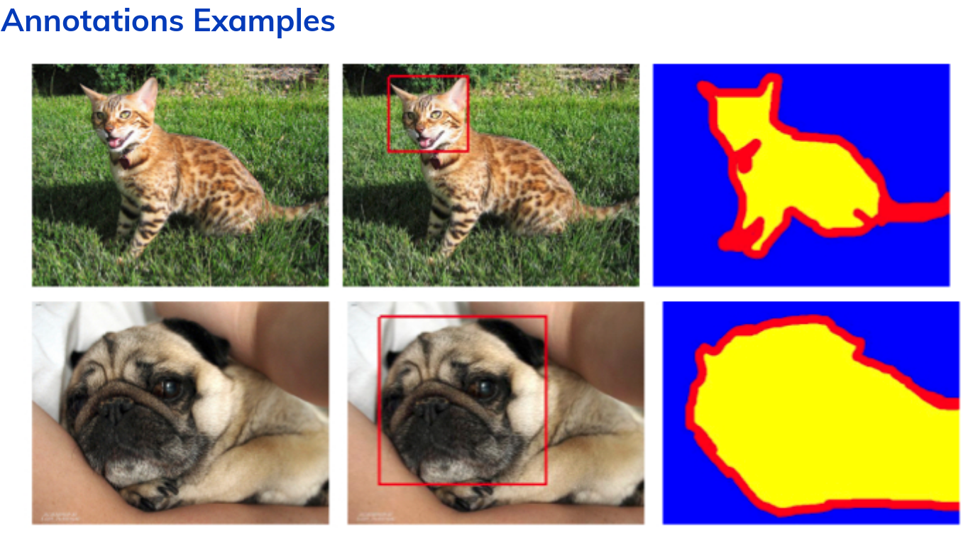
- Aerial Semantic Segmentation Dataset: https://www.kaggle.com/bulentsiyah/semantic-drone-dataset?select=dataset
